**Creating & loading data in table emp:**

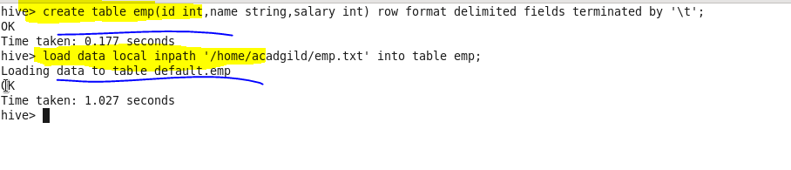

**Displaying table emp:**

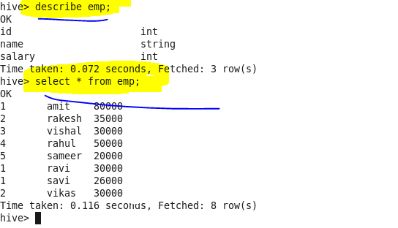

**Creating & loading data in table dept:**

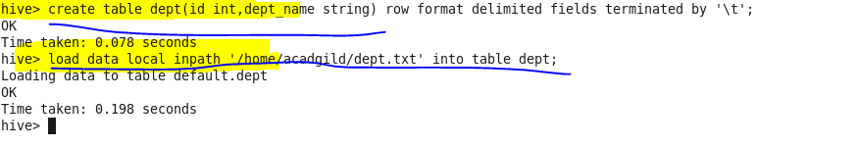

**Displaying table dept:**

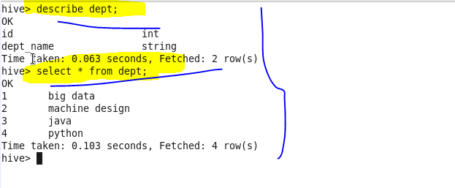

**Join table ordering (Largest table last):**

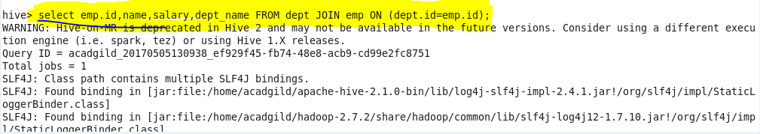

**Output:**

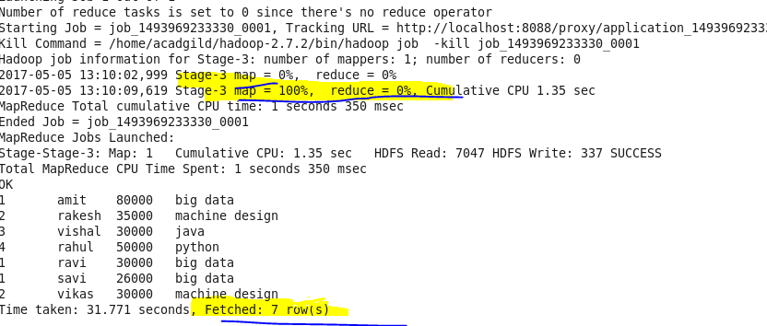

**Map Side Join:**

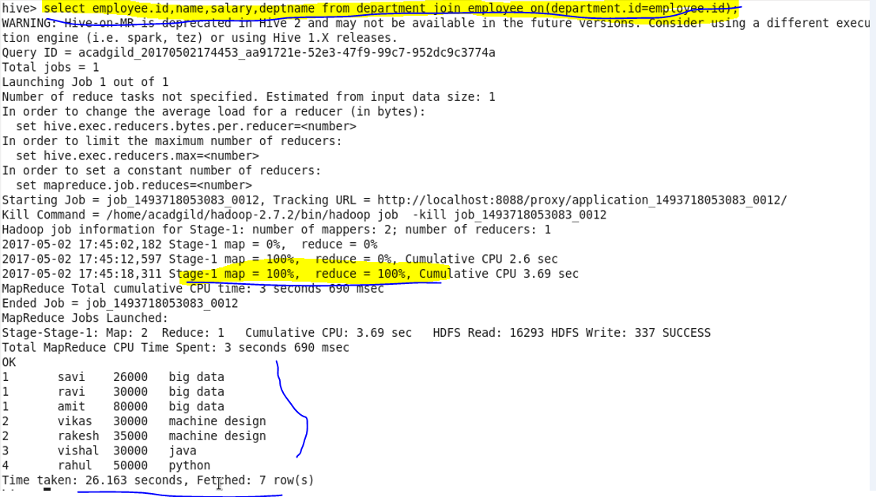

**hive> set hive.auto.convert.join=true;**

**hive> set hive.auto.convert.join.noconditionaltask=true;**

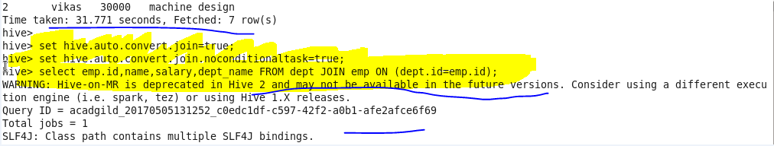

**Output:**

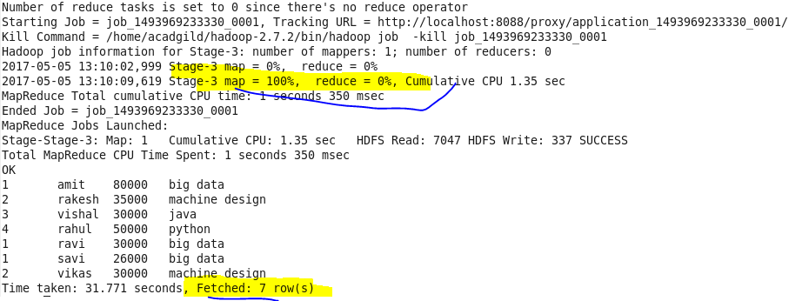

**Creating a bucket table emp:**

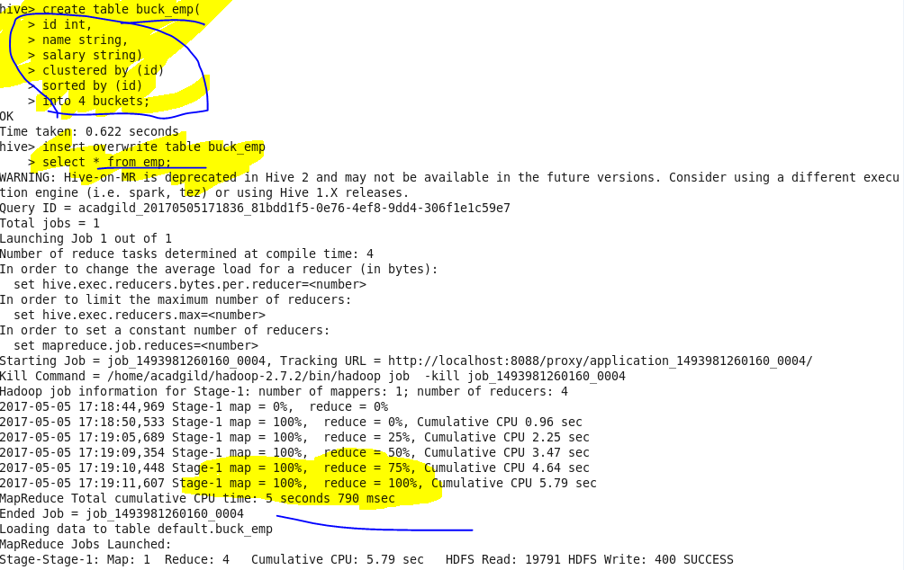

**Creating a bucket table dept:**

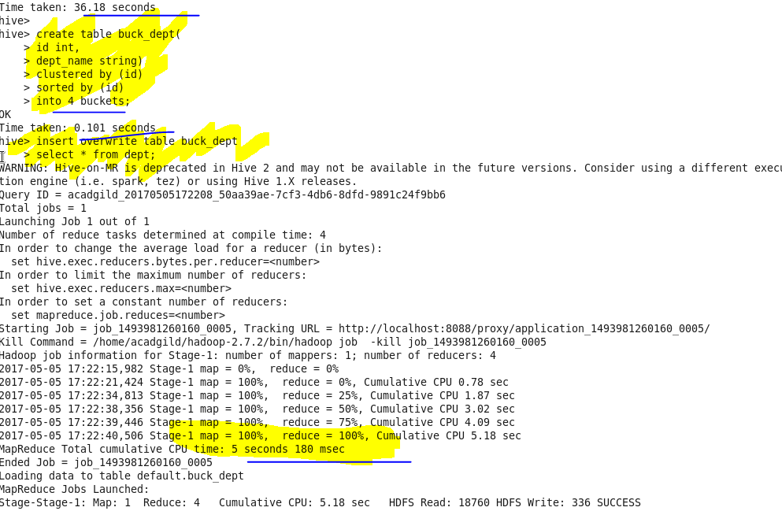

**Output:**

